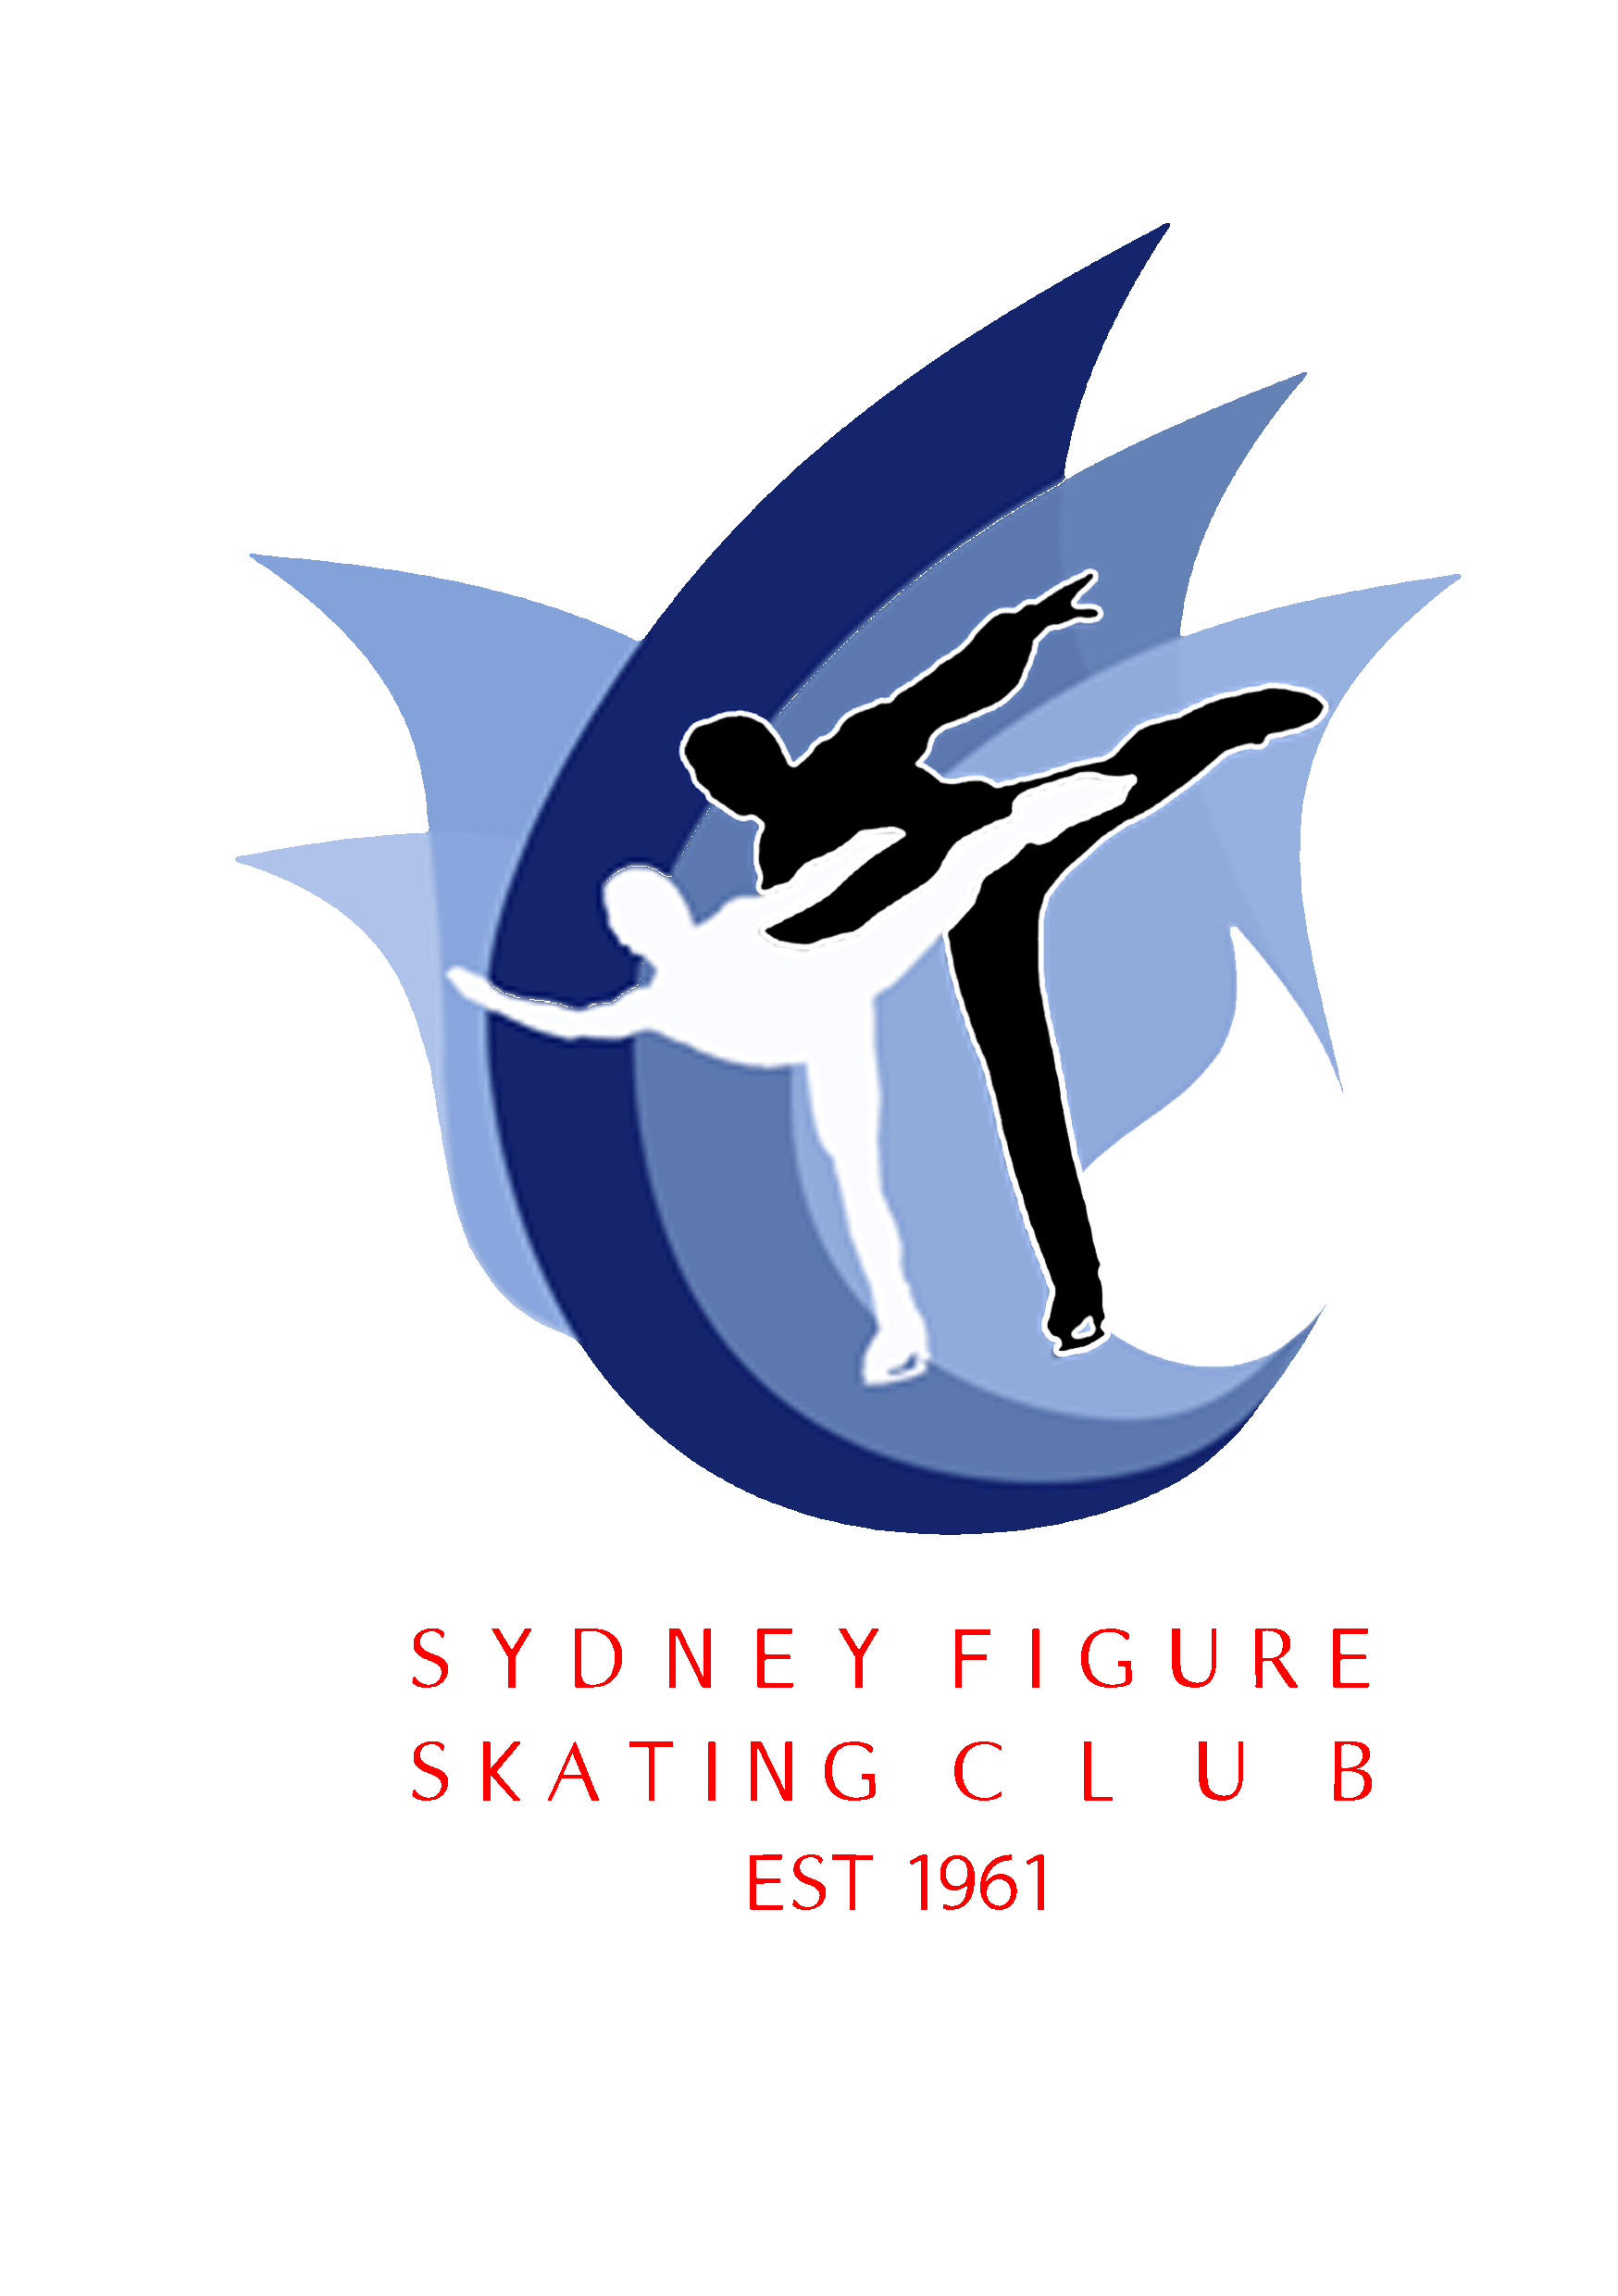
Sydney Figure Skating Club
47th Hollins Trophy June 5th – 8th 2015

2015 Hollins Trophy for Ladies
2015 Co-operative Cup for Men
2015 Carr’s Cup for Pairs
2015 Dance Cup

The Hollins Trophy, Co-operative Cup, Carr’s Cup and Dance Cup are International Interclub & Interstate events for Ladies, Men, Pairs and Ice Dance, sanctioned by Ice Skating Australia Inc and conducted in accordance with ISA & ISU Regulations. The Sydney Figure Skating Club aims to host a quality event providing the best available practice times for competitors.

The IJS (ISU Judging System) will be used for all Divisions.

Dates: |  | Friday June 5, Saturday June 6, Sunday June 7 & Monday June 8, 220152014.
 |  | 2015.
Venue: |  | Canterbury Olympic Ice Rink, Tasker Park, Phillips Avenue, Canterbury.

In accordance with ISA Regulations published on www.isa.org.au and ISU Regulations
& applicable ISU Communications published on www.isu.org.
NB: Technical Requirements for 2015-16 (see ISU Regulations and Communications for the 2015-16 season).
Please refer to the ISA and ISU websites for the latest information including ISU Communication 1886.
NB: 2015-16 REQUIREMENTS ARE APPLICABLE ONLY TO JUNIOR MEN & LADIES
SHORT PROGRAM EVENTS, AND JUNIOR & SENIOR PAIRS SHORT PROGRAM EVENTS.
For JUNIOR & SENIOR ICE DANCE EVENTS (See *ISU Communication 1932, 1936, 1937).
1
Singles
Preliminary Free Skating
Elementary Free Skating
Pre-Primary Free Skating (ISU Basic Novice A – ISU Communication 1886)
Primary Free Skating (ISU Basic Novice B – ISU Communication 1886) (Age requirements as per ISA)
Intermediate Free Skating (ISU Basic Novice B – ISU Communication 1886) (Age Requirements as per ISA)
Novice Short Program & Free Skating (ISU Advanced Novice -ISU Communication 1886)
Junior Short Program & Free Skating (ISU Rules 611 & 612, SP Group 2015-2016, ISU Communication 1861)
Senior Short Program & Free Skating (ISU Rules 611 & 612, ISU Communication 1861)

Pairs
Pre-Primary Pairs Free Skating (ISA Sections 3 & 6)
Primary Pairs Free Skating (ISU Basic Novice Pair – ISU Communication 1886) (Age requirements as per ISA)
Novice Pairs Short Program & Free Skating (ISU Advanced Novice -ISU Communication 1886)
Junior Pairs Short Program & Free Skating (ISU Rules 611 & 612, SP Group 2015-2016, ISU Communication 1861)
Senior Pairs Short Program & Free Skating (ISU Rules 620 & 621, SP Group 2015-2016 ISU Communication 1861)

Ice Dance
Elementary - Pattern & Free Dance – PD Group 1, Dutch Waltz, Canasta Tango, Free Dance, (ISA Rule
337, 339).
Pre-Primary – Pattern & Free Dance – PD Group 1, Canasta Tango, #1 Fourteenstep (ISA Rule 337, 339
/ISU Communication 1886)
Primary – Pattern & Free Dance – PD #1 Fourteenstep, #5 European Waltz (ISU Communication 1886 – submission of own music for European Waltz & FD. ISU Basic Novice, ISA Rules 337, 339),
Novice - Pattern & Free Dance – PD # 3 Rocker Foxtrot, #9 Starlight Waltz, (ISU Communication 1886/1932 – Advanced Novice – submission of own music for Starlight Waltz & FD).
Junior – Short & Free Dance – ISU Communications 1932 (Short Dance: Waltz plus any number of Foxtrot, March, Polka)
Senior - Short & Free Dance – ISU Communications 1932 (Short Dance: Waltz plus any number of Foxtrot, March, Polka)

If necessary, numbers may be limited due to ice-time availability.

Closing Date: Friday May 22, 2015
Late entries will not be accepted after the Draw
An additional fee of $75.00 will be charged for entries accepted after the closing date
Enquiries: Competition Convenor Joanne Rotondo jtrotondo@bigpond.com

Entry Fees:

Singles Preliminary, Elementary, Pre-Primary, Primary, Intermediate: $160.00
SFSC Representing Members $140.00
Novice, Junior & Senior: $190.00
SFSC Representing Members $170.00

Pairs Pre-Primary, Primary, Novice: $175.00 per pair
SFSC Representing members $155.00 per pair
Junior, Senior: $250.00 per pair
SFSC Representing members $230.00 per pair

Dance Pre-Primary, Primary, Novice: $175.00 per couple
SFSC Representing members $155.00 per couple
Junior & Senior: $250.00 per couple
SFSC Representing members $230.00 per pair

Please note the cost of Official Practices is included in the entry fee.
There is a gold coin donation for spectator entry.

Entries: - from Australia MUST be submitted via ISA State asociations
Entries – from New Zealand MUST be submitted via NZ Figure kating.
Entries from Affiliated Clubs in the above countries following notification (as applicable) to their National Federations, in accordance with ISU Rule 107.14. MUST be on the applicable entry form and be accompanied by the completed Planned Program Content Sheet (PPC) for all programs.

Entries to the SFSC Mailbox C/- Canterbury Olympic Ice Rink
Phillips Ave Canterbury NSW 2193
Or email to jtrotondo@bigpond.com
Cheque/money order made payable to: The Sydney Figure Skating Club. Or Direct Deposit to SFSC Westpac Bank BSB # 032-067
ACC # 212 880
No responsibility will be taken by SFSC for entries not delivered or mailed to the above destinations.

Withdrawals: Refund – only with medical certificate – a 10% deduction from the entry fee before the draw and no refund available after the draw.

Trophies: Trophies will be awarded to the first three placegetters in each event. The Perpetual Trophies will be retained by the Sydney Figure Skating Club and will be engraved with the winner’s name and displayed at Canterbury Olympic Ice Rink.

Music: Music MUST be sent through via email to nswisa.music@gmail.com or music can be uploaded on the NSWISA website. MP3 PREFERRED. Files MUST be saved with competitors full name and division entered. Vocal music is permitted.

Registration: The official registration desk will be located at the main entrance. Competitors must check in 1 hour before the event.

Draws:

The opening draw for all events will be conducted on Friday, May 29, 2015 and the Skating Order for each event will be published on Monday, June 1, 2015. Subsequent Skating Order for Novice, Junior & Senior events (Singles, Pairs & Dance) will be determined following the conclusion of the applicable event by reversing the results from the SP or SD for each event.

Judges:

Each State association of ISA, together with the NZ Ice Figure Skating Association Inc, ARE invited to nominate a Judge or Judges for any of the scheduled events, subject to their possessing the required qualifications for that level of judging. These nominations must be advised to the Sydney Figure Skating Club, email Joanne Rotondo at jtrotondo@bigpond.com
By the closing date

Photography:

An official photographer will be taking photos at the 2015 Hollins Trophy. Photos will be available for viewing and purchase. For private photographers, please note that no flash photography is allowed in practice, warm-ups or events, as it may be dangerous to the skaters. All private photographers are required to register at the Information/Registrations desk on the day of the event.

Video Recording: Individuals using video cameras will be required to register at the Information/ Registrations desk on the day of the event. Videoing can only be undertaken in the designated area and a written application is required. NO VIDEOING OF PRACTICE SESSIONS IS ALLOWED.

***ALL AUSTRALIAN COMPETITORS MUST BE REGISTERED & INSURED MEMBERS OF ISA, AS WELL AS THEIR STATE ASSOCIATION AND AFFILIATED CLUB AT CLOSE OF ENTRIES***

<<<ALL NZ COMPETITORS MUST BE FINANCIAL AND INSURED MEMBERS OF THE APPLICABLE ASSOCIATION/AFFILIATED CLUB AT CLOSE OF ENTRIES>>>

INFORMATION CONTAINED AS AT THURSDAY 16 APRIL, 2015 – SUBJECT TO CHANGE

